Home Learning for year 1 – week beginning 15th June.

Day.1.
Literacy: This week I have recorded myself reading the story of Tiddler by Julia Donaldson & Axel Scheffler. I hope you enjoy listening to it, I have missed telling you stories!

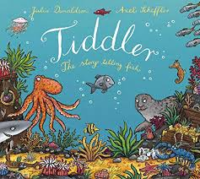

https://safeYouTube.net/w/zehL

Can you answer these Comprehension questions?
- Why was Tiddler always late?
- Can you name 2 of Tiddler’s adventures?
- Where did Tiddler get taken to?
- How did Tiddler get home?
- What do you think the moral/message of the story is?

Draw a picture of Tiddler on one of his adventures.

Numeracy:
This week we are still thinking about weighing for Day 1 Numeracy and a Maths test for Day 2 Numeracy.

What did you weigh last week?
Did you manage to use ingredients?

Try the new Balance Weighing sheet that I have attached for you on the School Website.
If you don’t have a balance scale, can you try making your own? I have attached some instructions for you.

Remember how many grams to 1 kilogram?
How heavier or lighter is your object?

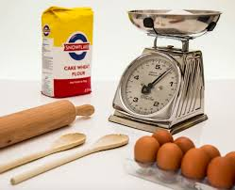

Science:
Today we are thinking about what different animals eat and how it helps them survive.
The 3 key words are: Carnivore, Herbivore, Omnivore.
What do these words mean? Can you write down 2 facts for each type of animal?
You can put them in a little chart like this to show how they are different:-
Carnivore | Herbivore | Omnivore | Picture of animal

I have attached some pictures on the website of each type of animal.

Day.2:

Literacy:
Listen to Tiddler again and can you describe one of the fish’s characters?
If you were one of the fish, who would you be?
Would you be Tiddler? The Stingray? Rabbitfish? Little Johnny Dory?
What do you look like? How do you act? What do you feel about the other fish?
Remember to illustrate your work when you have finished.

I have also put this week’s spellings on the School website for you to practice all week.
Numeracy:
Today I would like you to finish making your balance scales and keep practising your weighing skills.
When you have finished, can you try this week’s Maths test on the School website?
No cheating, the answers are on the test for your parents!

P.E:
I hope you are all still staying active? Even if you just go for a short walk each day or try doing 20 star jumps?

I have an extra activity for you this week. If you would like some Art work to keep you going over the Summer holidays when they arrive, click on this link. You can make your own lockdown diary or book. There is a lovely animals book you can make which will help with our Science topic.
It is not compulsory but just a fun activity for you to do over the Summer.
The website is called Art projects for Schools.

https://www.apfs.org.uk/activitybooks
Maybe you can make a book like these!
