Year 1

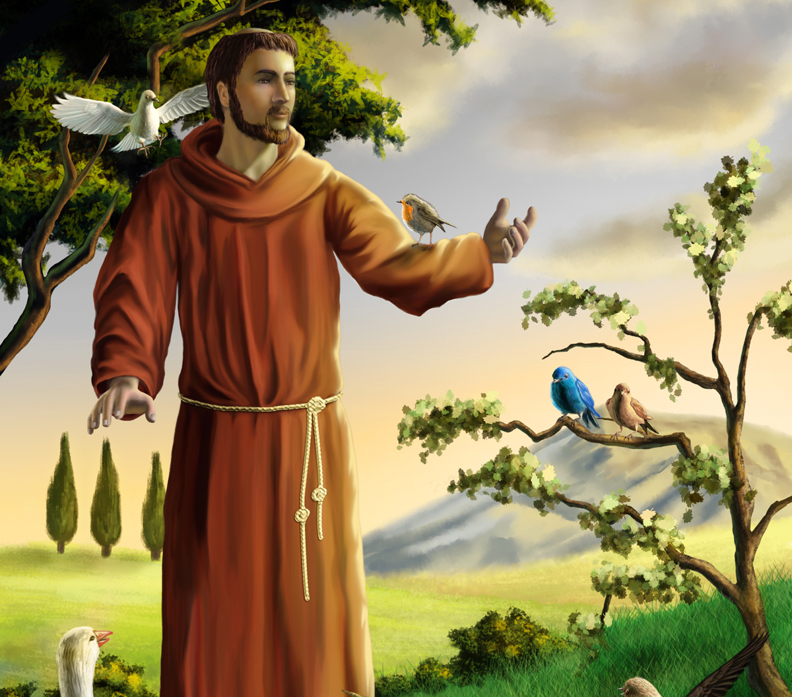 | RE  Our R.E. topics are Families, Belonging and Waiting (Advent). We will also be looking at Judaism for one week. Our class saint is St. Francis of Assisi. Children will learn to:  • Retell Bible stories.  • Recognise religious beliefs  • Describe some religious beliefs  • Recognise that people act in a particular way because of their beliefs  • Describe some of the actions and choices of believers that arise because of their belief  • Recognise key figures in the history of the People of God.  Children will have opportunities to take part in conversations where they can talk about and ask questions about Christianity. | English  In our Literacy lessons, we are looking at, stories about toys and will be doing writing activities based on the Toy Story films. We will be writing descriptions, letters, diaries and instructions. We will be learning how to write longer and shorter sentences and using adjectives to add interest to our sentences. We will be particularly focusing on initial and final sounds in words, vowel sounds and rhyming word families. We will read and base our writing around; The Teddy Bear Robber. We will have daily Phonics lessons where the children will learn digraphs and how to read and spell ‘tricky words’. The children will able to recognise different types of texts (instructions, diaries, stories, letters and newspapers). The children will begin to write words and simple sentences independently. We will focus this term on finger spaces and full stops. The children will practice saying a sentence and then writing a sentence.  Phonics- Little Wandle scheme – The children have x2 reading practice sessions per week.
Geography/History  Our History topic is Toys and we will be learning about how toys have changed throughout the years. We will be comparing old and new toys and learning about what children from different decades played with compared to what they like playing with.  In Geography, we are beginning to identify other places in the world and locate them on a map. | 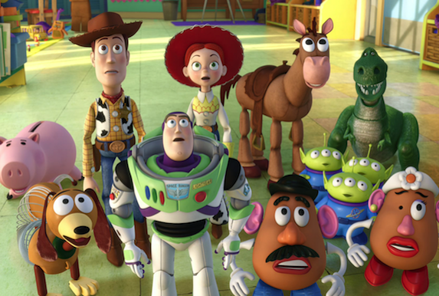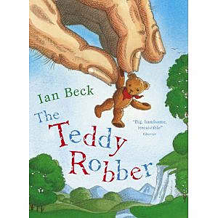  Autumn Term | PE/Games  In P.E we will be doing dance and multi skills.  In Dance children will learn to:  - Copy simple movement patterns from each other and explore the movement.  - Practise and repeat their movement phrases and perform them in a controlled way.  In games the children will learn to:  - Throw and catch a ball with a partner.  - Move fluently, changing direction and speed easily and avoiding collisions.  - Show control and accuracy with the basic actions for rolling, underarm throwing, striking a ball and kicking.
DT/Art  In Art we will be painting and using watercolours, collage, and crayons. We will be looking at various artists and different media they have used. Our D.T. topic is ‘Eat more Fruit and Vegetables’ & ‘Sewing Skills’. | Science  In our Science lessons, we will be thinking about ‘Seasonal Changes & Materials’. Children will learn to sort and group materials and use appropriate adjectives to describe the materials, giving reasons why they are used because of their properties. We will experiment the best material to use for weather proofing or to keep things hot or cold. | Maths  In our Maths lessons we will continue to focus on counting patterns, strategies for addition and subtraction, money values and the properties of shape. Children will be expected to practise counting on and back to 30 and also to learn their number bonds to 20 at home. For example: 6+4, 15+5. Children will learn part-whole models and the place value of numbers. They will be able to order numbers and count to and back from 100. We will be doubling and halving numbers.
Computing  In Computing, we will be identifying how we use technology in our lives and how to use it safely. We will also look at basic instructional language in order to code a Beebot. | Music  We will be able to sing simple songs from memory with enjoyment, some expression and a sense of the shape of the melody. In addition, we will use our voices confidently in a variety of ways, identify pulse in music as well as recall short rhythmic and melodic patterns. | PSHCE  In PSHE we will follow our ten ten scheme where we will have weekly discussions.

 | RE  Our R.E. topics are Special People, Meals and Change. Children will learn to:  • Retell Bible stories.  • Recognise religious beliefs  • Describe some religious beliefs  • Recognise that people act in a particular way because of their beliefs  • Describe some of the actions and choices of believers that arise because of their belief  • Recognise key figures in the history of the People of God.  Children will have opportunities to take part in conversations where they can talk about and ask questions about Christianity.  This term we are going to be celebrating Sikhism in class. | English  In our writing lessons we are looking at stories about pirates and will be doing writing activities based on pirates. We will be writing descriptions, letters, diaries and instructions. We will be particularly focusing on spelling tricky words correctly. We will have daily phonics lessons where the children will learn diagraphs and how to read and spell tricky words. The children will be able to recognise different types of texts (instructions, diaries, stories, letters and newspapers). The children will begin to write words and simple sentences independently. We will focus ion adjectives, and exclamation marks and the children will also begin to use question marks. The children will start to write more and will be writing in role and retelling.  We will be doing are writing around lots of different pirate books.  Phonics- Little Wandle scheme – The children have x2 reading practice sessions per week.
Geography  Our Geography topic is the United Kingdom and we will be looking at maps. We will be learning about the countries that make up the United Kingdom and famous landmarks. We will learn about the continents and oceans that make up our world and be able to locate them on a map. | 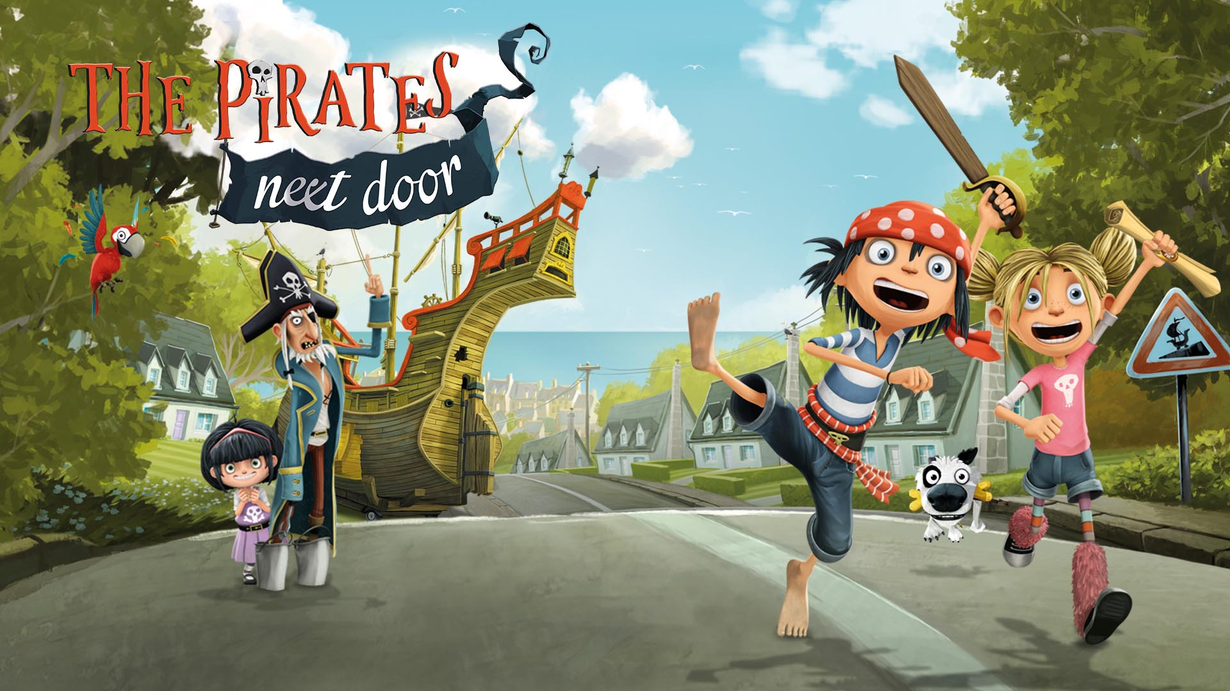  Spring term | PE/Games  In P.E we will be doing gymnastic skills.  Children will learn to:  - Balance with control.  - Use their bodies to make shapes and begin a variety of gymnastic rolls.  In games the children will learn to:  - Throw and catch a ball with a partner.  - Move fluently, changing direction and speed easily and avoiding collisions.  - Show control and accuracy with the basic actions for rolling, underarm throwing, striking a ball and kicking.  - Continue to use multi skills practice.
DT/Art  In Art we will mixing primary and secondary colours, use a variety of different media such as pastels and charcoals and experiment with different size of lines, begin printing and using different materials such as clay.  In DT we will continue to use cutting skills and make a structure. | Science  During science this term, we are starting a new topic on ‘Plants’. Children will have the opportunity to plant and watch seeds grow, learn about a variety of plants such as flowers, vegetables and trees. We will use our wonderful school environment to observe winter to spring changes and watch how nature changes and grows. We will look at the different parts of a plants and relate to living and non - living things. 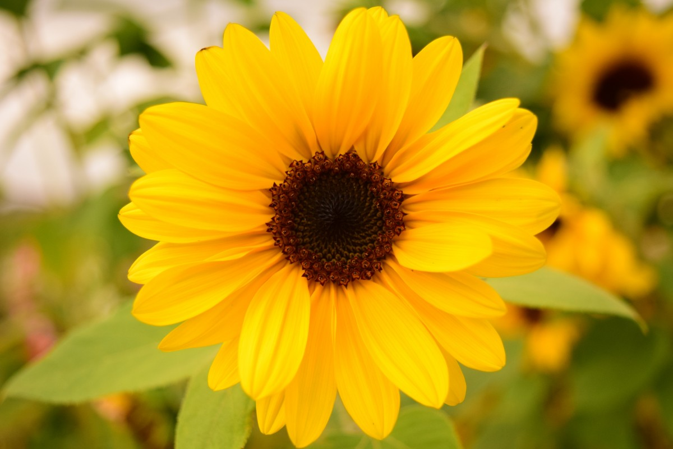 | Maths  In our Maths lessons we will continue to focus ordering of numbers, odd and even, more or less, sharing, halving and doubling. Children will be expected to practise counting on and back to 50 or 100 and continue to learn their number bonds to 20 at home., so they have a secure knowledge of place value, for example: know that 20 is 2 tens, 34 is 3 tens and 4 ones. Children will continue to revise time, money and shape topics in maths and how we use them in everyday life. We will be doing work on measure. They children will be using cubes to measure and balancing scales to compare the weight of objects. The children should start to feel more confident with their number bonds.
Computing  In Computing, we are looking at what is technology?  The children will work on their mouse skills and become confident using the netbooks. We will also look at safety. | Music  They will be able to sing simple songs from memory with enjoyment, some expression and a sense of the shape of the melody. In addition, they will use their voices confidently in a variety of ways, identify pulse in music as well as recall short rhythmic and melodic patterns. | PSHCE  In PSHE we will follow our ten ten scheme where we will have weekly discussions.

 | RE  Our R.E. topics are holidays & holydays, being sorry and neighbours. Children will learn to:  • Retell Bible stories.  • Recognise religious beliefs  • Describe some religious beliefs  • Recognise that people act in a particular way because of their beliefs  • Describe some of the actions and choices of believers that arise because of their belief  • Recognise key figures in the history of the people of God.  Children will have opportunities to take part in conversations where they can talk about and ask questions about Christianity.  This term we will be learning more about Hinduism. We will explore the traditions, stories and beliefs as well as looking at the similarities and differences with the Christian beliefs.  This term we will also be learning about Buddhism as our other faith. | English  In our writing lessons, we are looking at, stories about castles and dragons. We will be writing descriptions, letters, diaries, newspapers, stories, retell, information texts and instructions. We will start to lean about paragraphs and continue to focus on using a range of punctuation. We will have daily phonics lessons (Little Wandle) where the children will learn diagraphs and how to read and spell tricky words, we will focus on reading nonsense words in preparation for our Phonics test. The children will be able to recognise different types of texts (instructions, diaries, stories, letters and newspapers). The children will continue to write words and simple sentences independently.
Geography/History  Our History topic this term is Knights and Castles. We will be learning all about the features of castles and knights. We will learn about the Battle of Hastings and make comparisons. | 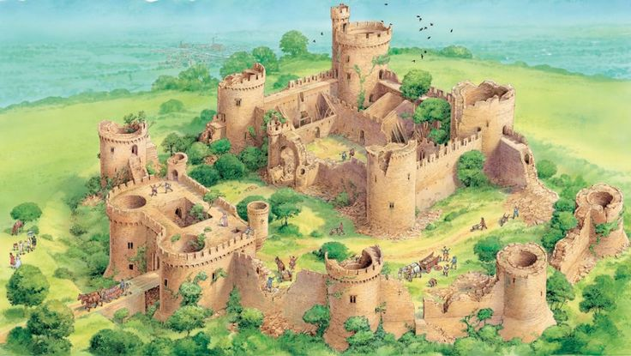  Summer Term | PE/Games  In P.E we will be doing gymnastic skills. Children will learn to:  - Balance with control.  - Use their bodies to make shapes and begin a variety of gymnastic rolls.  In games the children will learn to:  - Throw and catch a ball with a partner.  - Move fluently, changing direction and speed easily and avoiding collisions.  - Show control and accuracy with the basic actions for rolling, underarm throwing, striking a ball and kicking.  - Continue to use multi skills practice.
DT/Art  In DT we will continue to use cutting skills and make and design our own castle structures. We will be working in groups.  In art we will be using water colours to paint landscapes. We will be learning how to sketch and looking at light and dark. | Science  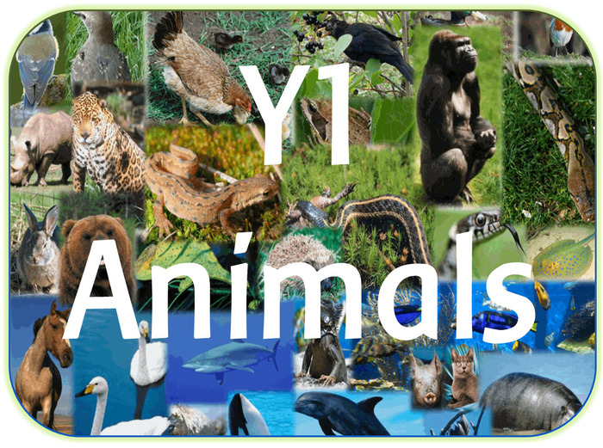  During science this term, we are starting a new topic on Animals.  The children will learn to classify animals into different groups. They will learn key vocab such as mammals, reptiles, amphibians and birds.  We will also look at sorting animals into herbivores, carnivores and omnivores. | Maths  In our Maths lessons we will continue to focus ordering of numbers, odd and even, more or less, sharing, halving and doubling. Children will be expected to practise counting on and back to 50 or 100 and continue to learn their number bonds to 20 at home, so they have a secure knowledge of place value, for example: know that 20 is 2 tens, 34 is 3 tens and 4 ones. Children will continue to learn time, money, shape and measure in maths and how we use them in everyday life.  This term we are focusing on maths reasoning and having discussions around number.
Computing  In Computing, we will continue to learn instructional language to use with IPads for a purpose. We will also look at how we use technology safely. We will be learning how to use Paint programme on the netbooks. | Music  They will be able to sing simple songs from memory with enjoyment, some expression and a sense of the shape of the melody. In addition, they will use their voices confidently in a variety of ways, identify pulse in music as well as recall short rhythmic and melodic patterns. | PSHCE  In PSHCE we will follow our ten ten scheme where we will have weekly discussions.

