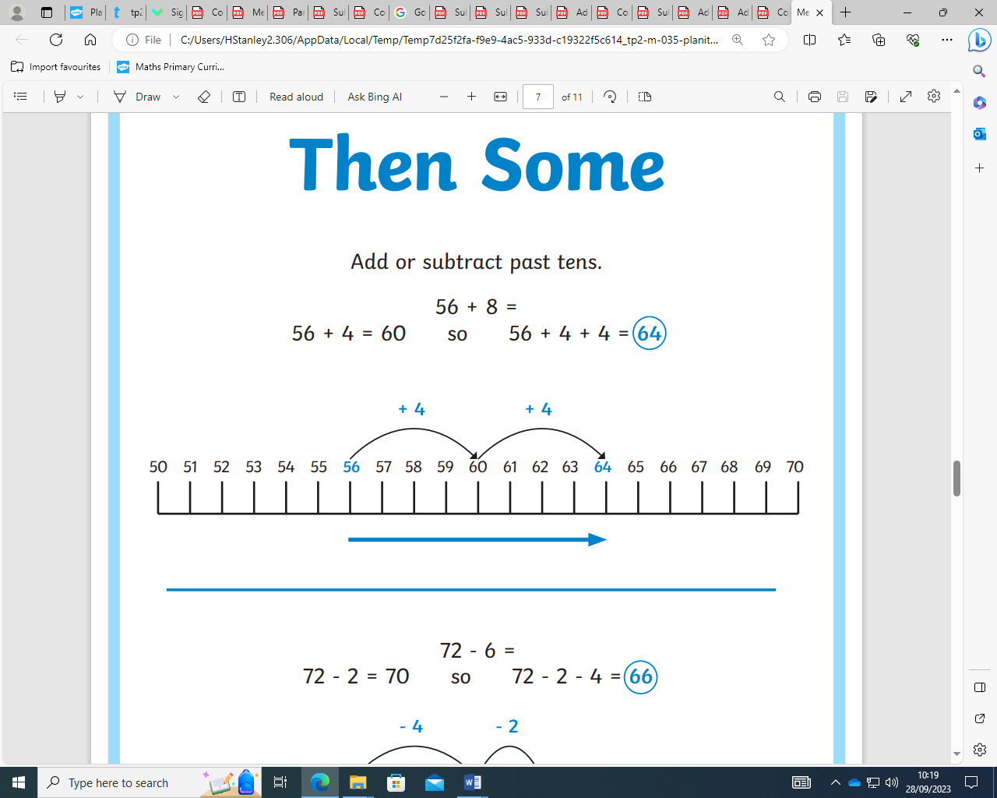

**Words I should use:**

* Add, addition, plus, more than, total, sum, altogether
* Subtract, subtraction, minus, take-away, less than, difference between
* Multiply, times, groups, product, lots of, multiple
* Divide, share equally, equal groups
* Factors, multiples

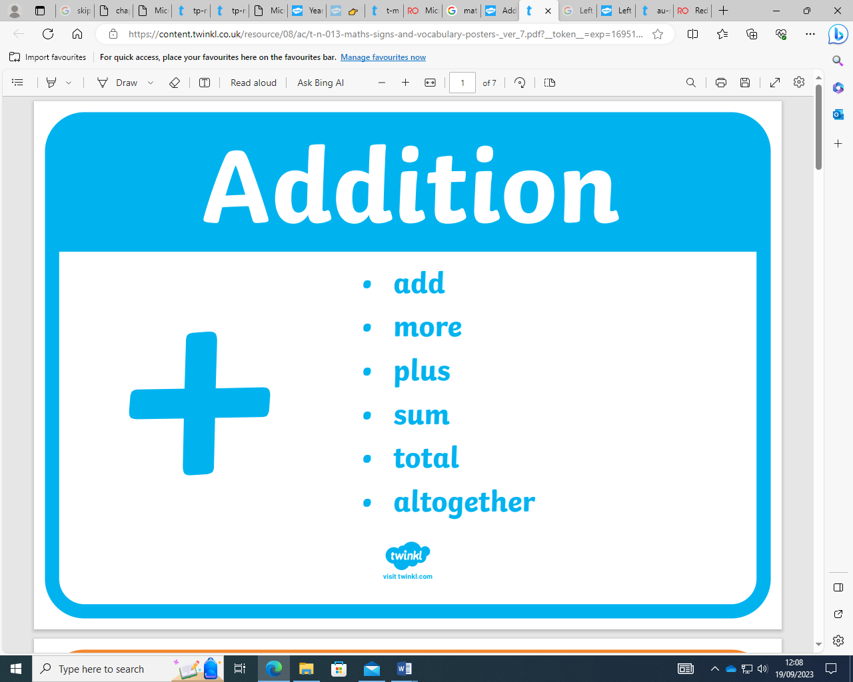 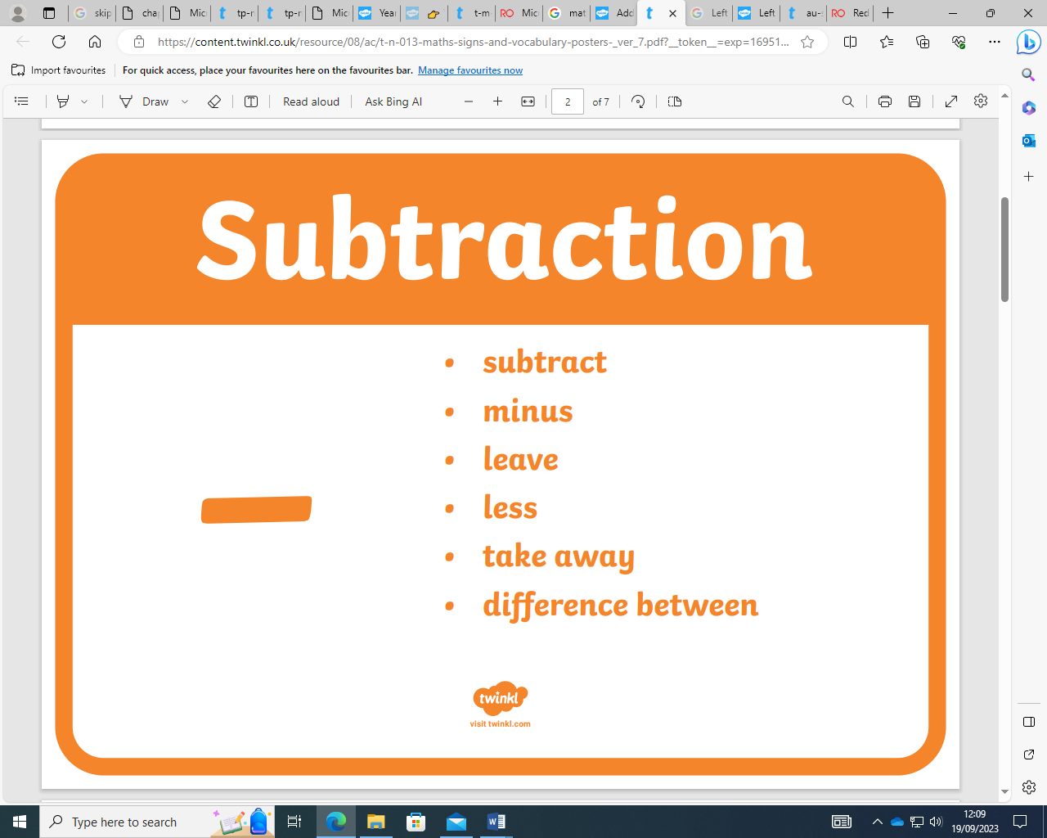

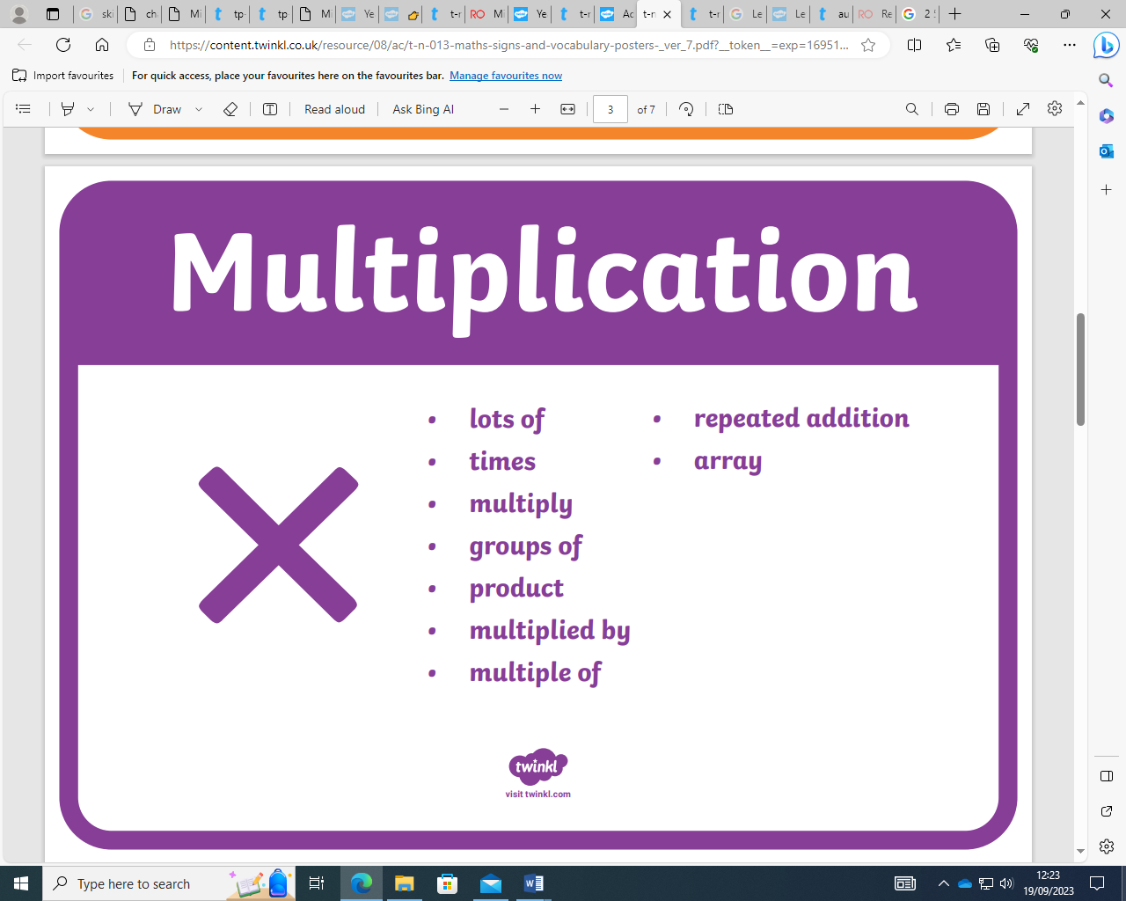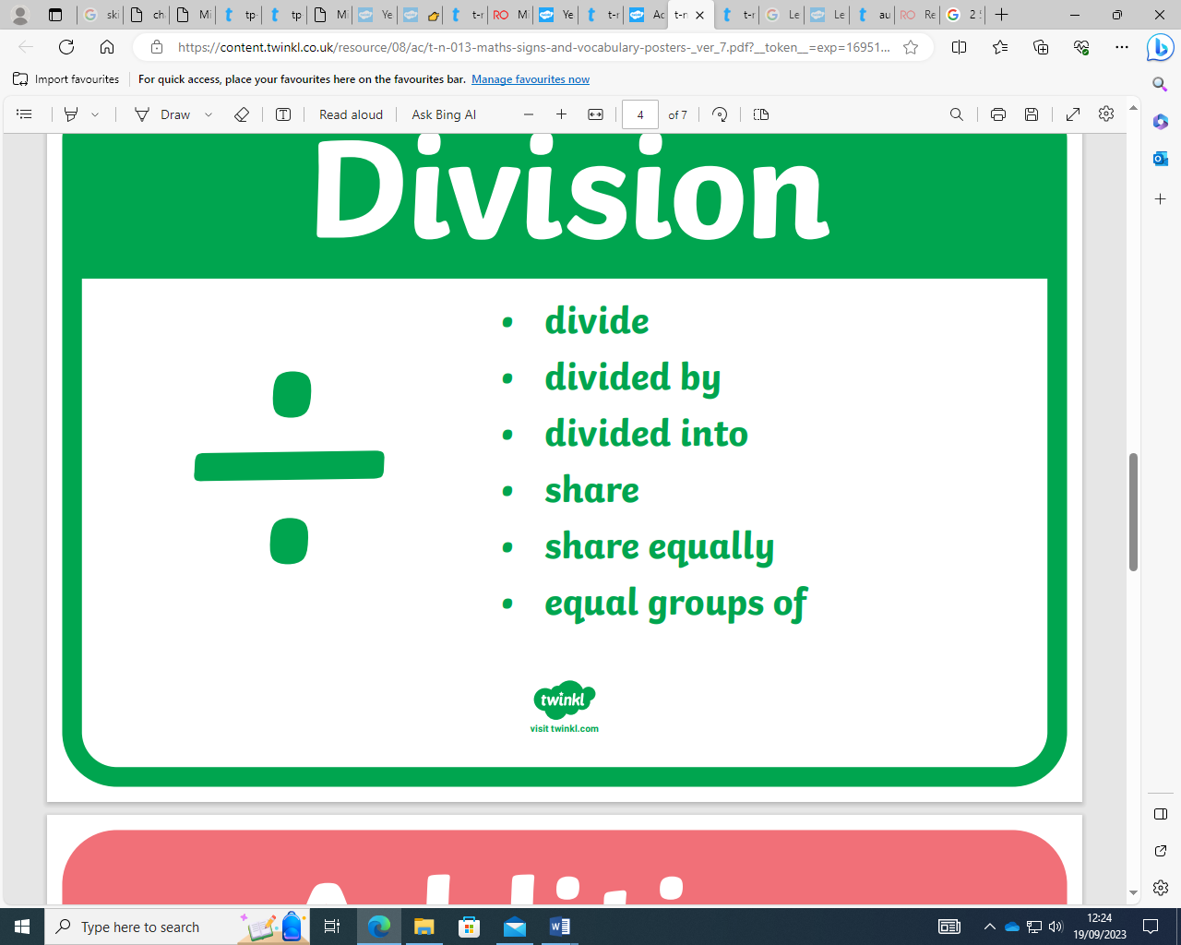

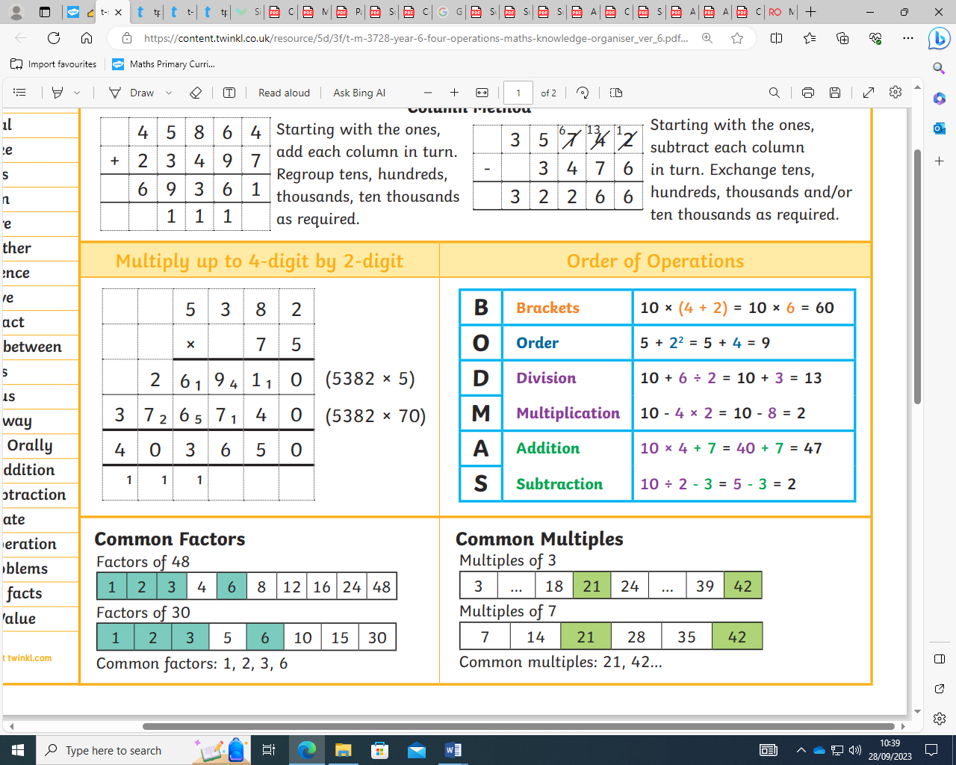



I can:

**Addition, Subtraction,**

**Multiplication and Division**

**Year 6**